Remove that section (09 Years of experience) form services page
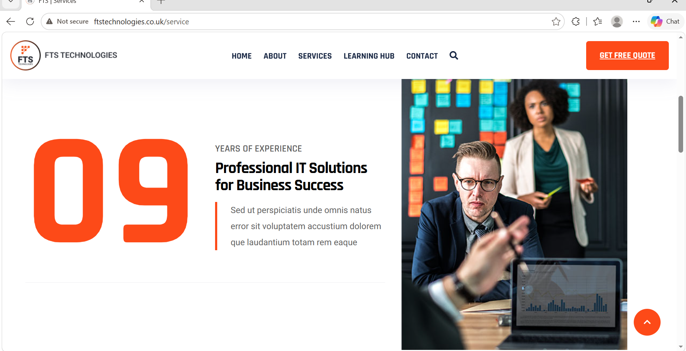

Add that services

AI Automation Solutions
Streamline business operations with intelligent automation, AI agents, workflow optimisation, document processing, and process automation solutions that improve efficiency and reduce manual effort.

AI Healthcare Solutions
Develop healthcare-focused AI systems including clinical decision support, healthcare analytics, medical NLP, mental health AI, and intelligent healthcare applications.

Custom AI platform
Design and build custom AI-powered web applications, SaaS platforms, chatbots, AI assistants, data intelligence tools, and enterprise AI solutions tailored to business needs.
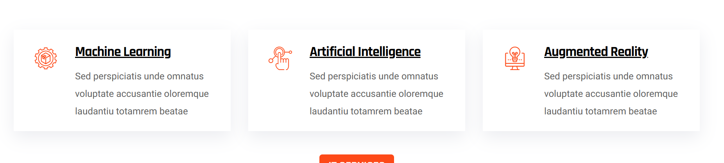

Specialized Solution Areas

AI Customer Support Agents
Intelligent AI agents for customer service, ticket handling, lead qualification, and 24/7 support automation.

Healthcare Decision Support Systems
AI-powered clinical insights, patient risk assessment, healthcare analytics, and medical workflow optimisation.

Healthcare Chatbots
Conversational AI for patient engagement, clinical note analysis, medical document summarisation, and healthcare assistance.

Web Applications
End-to-end development of AI-powered platforms, internal business tools, enterprise applications, and SaaS products.
